**Practical-2**

**Aim: -** Recognition of various type of connectors (**RJ45, RJ-11, BNC and SCST)**

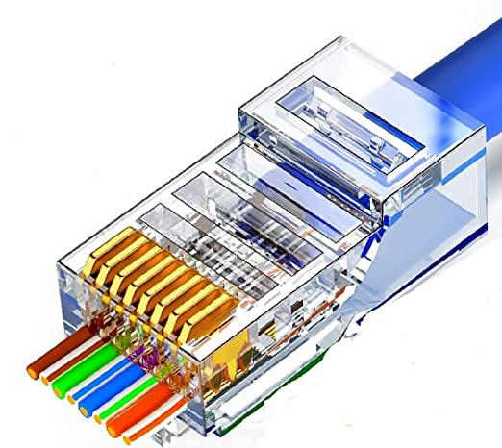**RJ45 Connector**: - The 8 pin RJ45 Connector is a standard interface which connects a computer to a local area network. This type of connectors connects a computer to a local area network. This type of connector was originally developed for telephone communication, but is now use in a range of application. The abbreviation RJ45 Stands for Registered Jack 45. Ethernet cables with RJ45 Connectors are also called RJ45 cables.

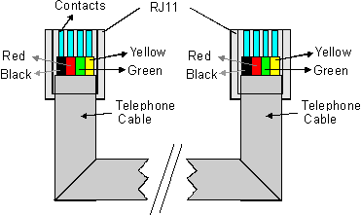

**RJ11 Connector: -** RJ11 is a four pin connector which is used for terminating the telephone wire. The RJ11 technically uses the center to context to six and used for wiring a single phone line. It is the single connector plugging into the wall and the handset into the telephone.

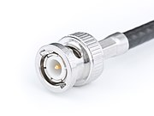**BNC Connector: -** The BNC connector is used for composite video on commercial video devices. BNC connector is the most connector for the CCTV security and surveillance system and is used to connect coaxial cable to CCTV cameras. BNC connector is used in Coaxial cable for quick connector of radio frequency.

**SCST Connector: -**

* **SC** and **ST** connector are used for connecting fiber optic cabling to networking devices. The **SC** stand for subscriber connectors and **ST** stands for Straight Tip.
* **Connector Type** both are recognized by electronic industry, telecommunication industry, SC connector are used in data communication and telephony environments. We can use SC and St connector with either single mode or multiple mode.